training 1 epoch...

1029.0374505519867 seconds used......

1 training finished! average train loss: 0.28910239601899473

evaluating...

Confusion matrix, without normalization

[[ 111 156 27]

[ 131 3612 78]

[ 13 47 782]]

Normalized confusion matrix

[[0.37755102 0.53061224 0.09183673]

[0.03428422 0.94530228 0.0204135 ]

[0.01543943 0.05581948 0.92874109]]

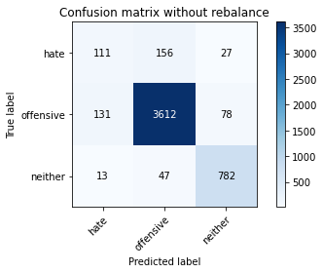

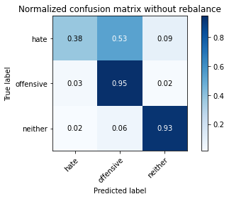

precision recall f1-score support

hate 0.44 0.38 0.40 294

offensive 0.95 0.95 0.95 3821

neither 0.88 0.93 0.90 842

accuracy 0.91 4957

macro avg 0.75 0.75 0.75 4957

weighted avg 0.91 0.91 0.91 4957

average eval_loss: 0.24080348565465465, accuracy: 0.9088158160177526

training 2 epoch...

1028.3183164596558 seconds used......

2 training finished! average train loss: 0.20677236193416249

evaluating...

Confusion matrix, without normalization

[[ 73 194 27]

[ 45 3662 114]

[ 11 34 797]]

Normalized confusion matrix

[[0.24829932 0.65986395 0.09183673]

[0.01177702 0.95838786 0.02983512]

[0.01306413 0.04038005 0.94655582]]

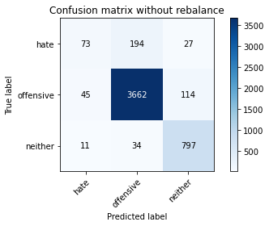

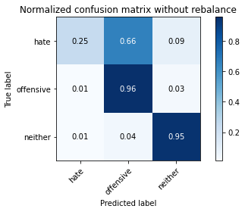

precision recall f1-score support

hate 0.57 0.25 0.35 294

offensive 0.94 0.96 0.95 3821

neither 0.85 0.95 0.90 842

accuracy 0.91 4957

macro avg 0.79 0.72 0.73 4957

weighted avg 0.90 0.91 0.90 4957

average eval_loss: 0.251087358812281, accuracy: 0.9142626588662498